Home Network topology

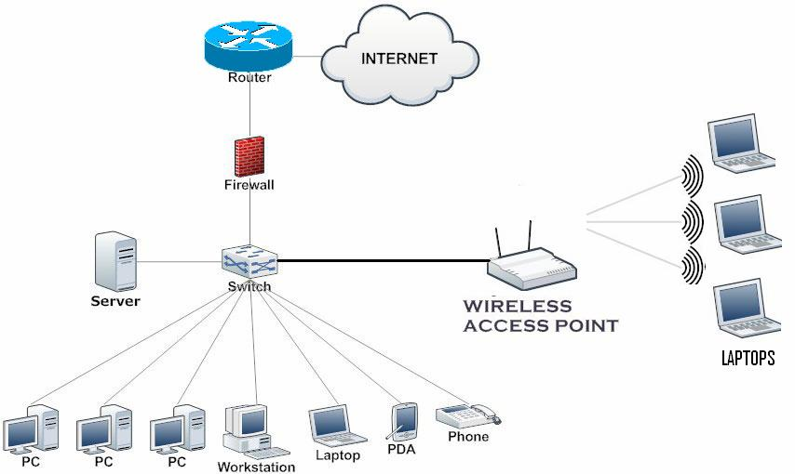

This diagrams shows how the wired and wirless devices connected to a local area network.It shows that the internet is connected with router which controls the traffic between local network and the external network. Router is a barrier between the internet and the local network and the firewall protects from the unauthorized accessibility. Switch that connects multiple wired devices like PC, server, workstation, laptop, phone etc. The wireless access points allows wireles devices like laptops.Server is the part of network used to provide file storages,databases to the connected devices.